# Move an existing Notebook to OneDrive

BCBSAZ currently maps your Notebooks to the F drive but with the upcoming Office upgrade, this will change to OneDrive. Get ahead of the game by making the change now. This will help ensure no data is lost when you upgrade to Microsoft Office 365.

1. Open the notebook you want to move then click **File** in the menu to bring up the screen below. Click **Settings** for the notebook you want to move.

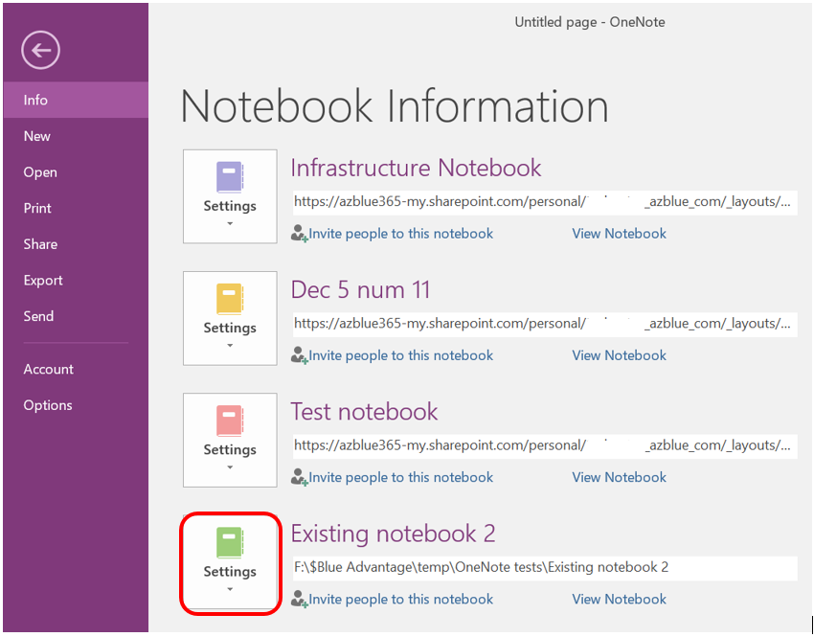

1. Click **Properties**, then click **Change Location**.

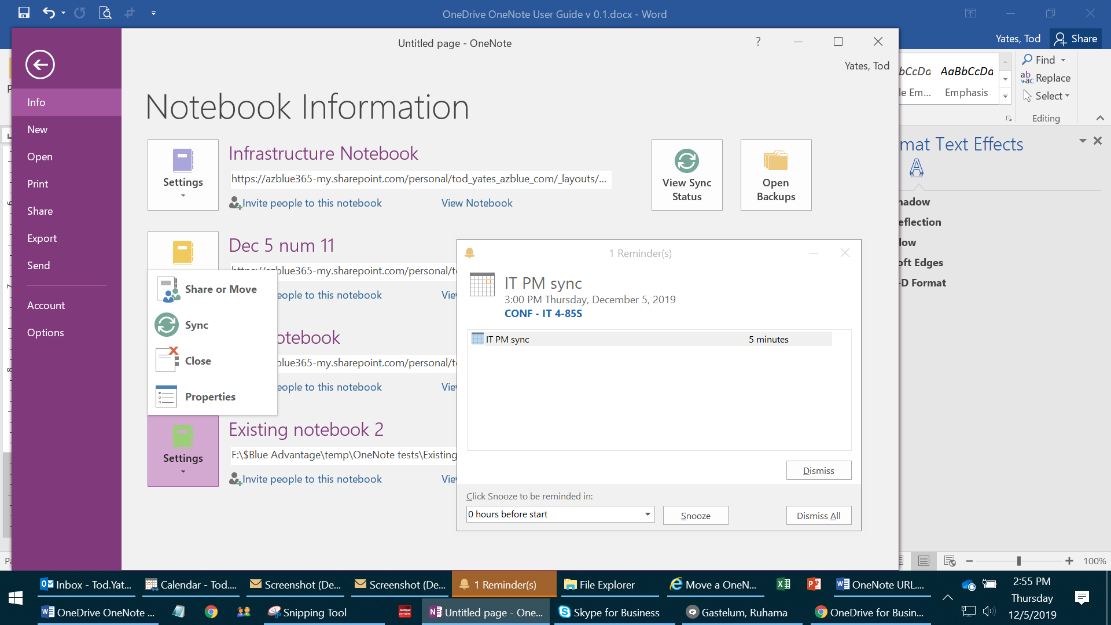 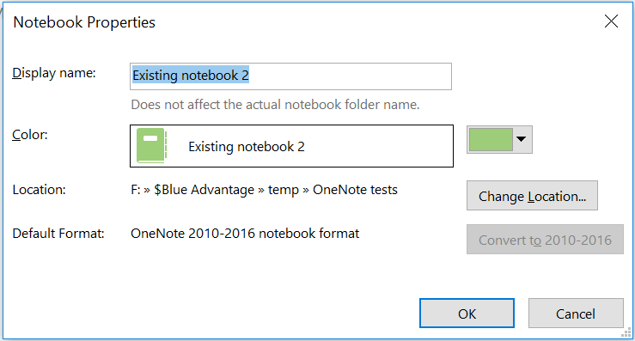

1. Copy this string to your clipboard after adding your name into it: [https://azblue365-my.sharepoint.com/personal/***userFname***_***userLname***_azblue_com/](https://azblue365-my.sharepoint.com/personal/userFname_userLname_azblue_com/)

**Make sure you replace** **the userFname and userLname with your first and last name**. Paste that string into the address bar using the following directions:

1. Click in the white space of the address bar as indicated below; the border will be highlighted in blue.

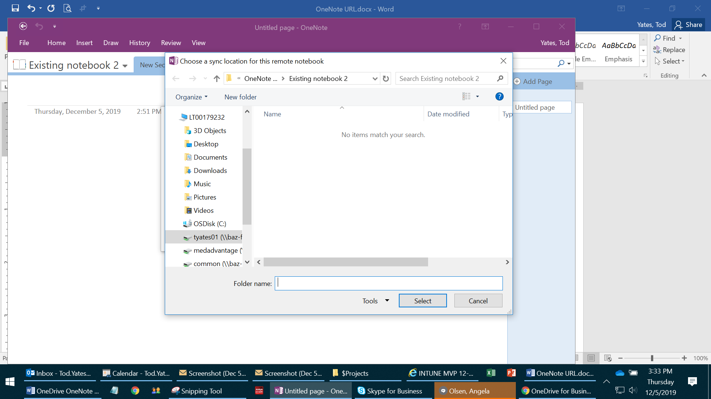

1. Paste the URL you copied above using CTL-V and click the arrow to the right of the address bar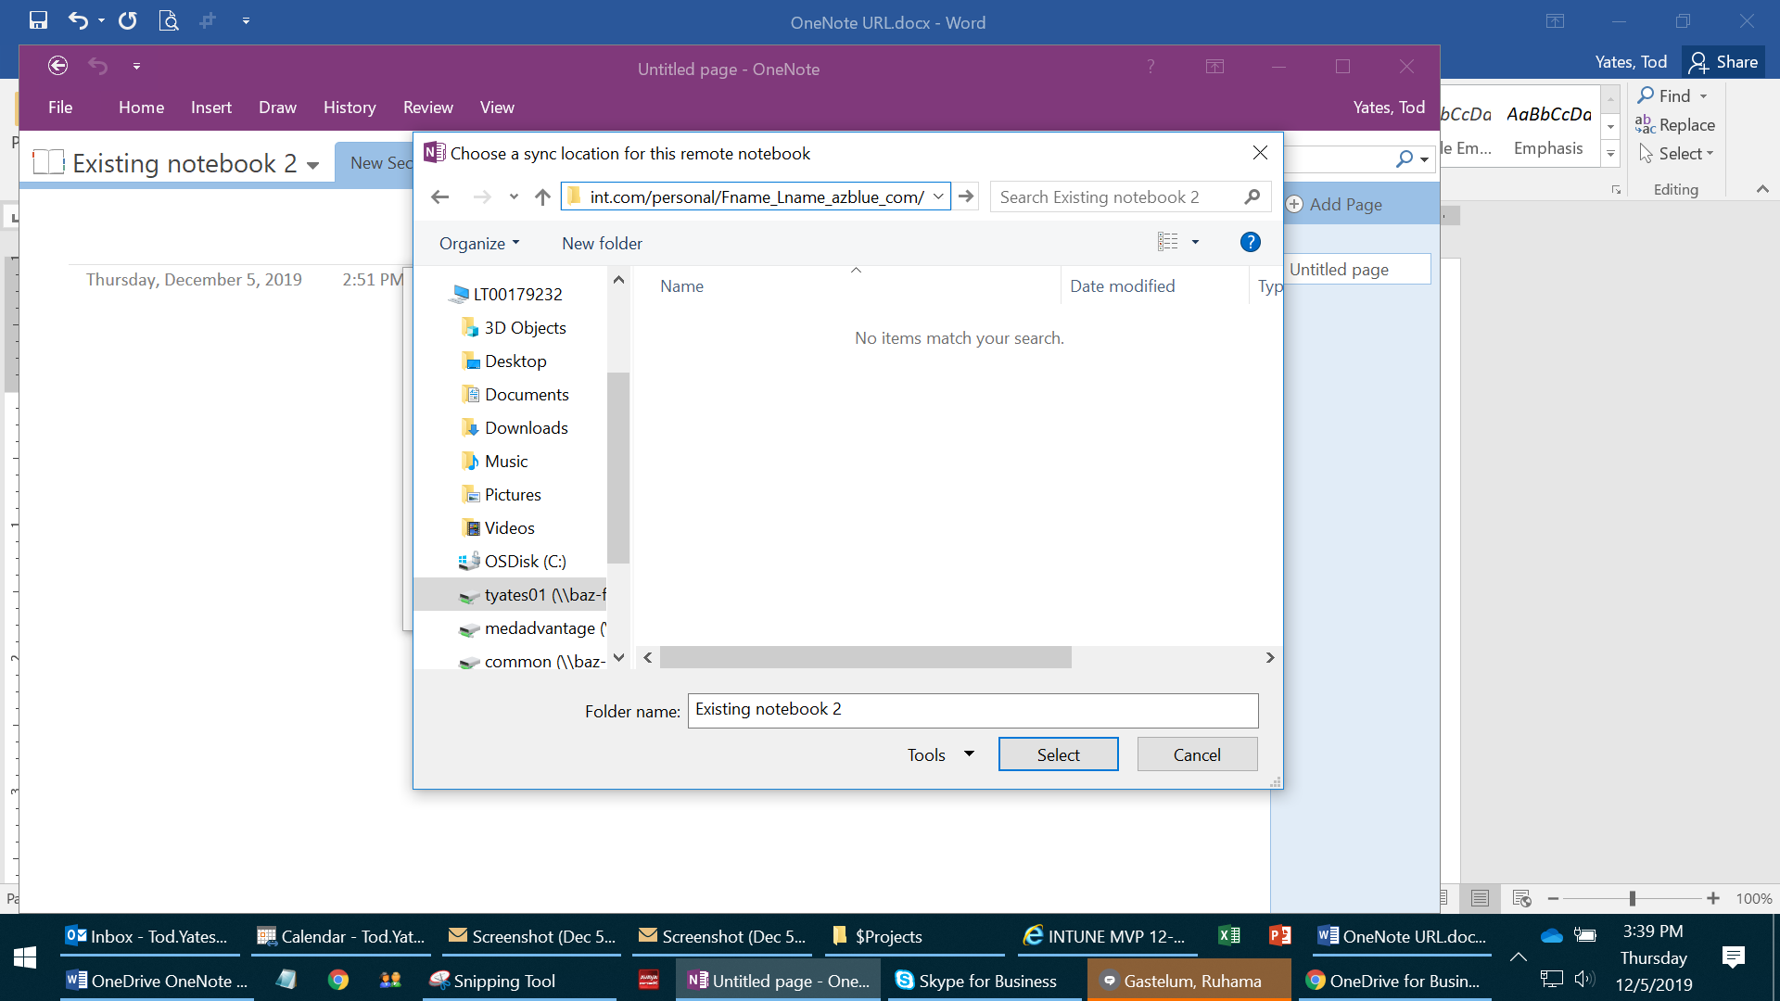
2. Double-click Documents and click Select.

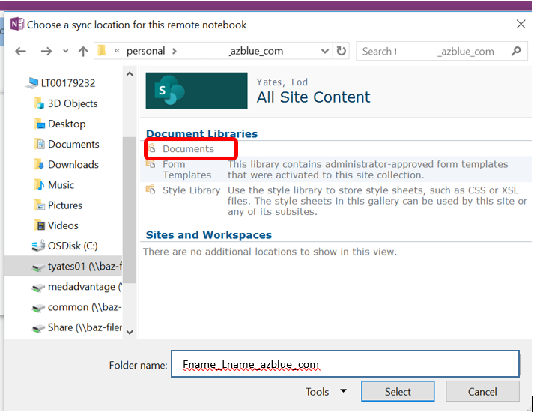

1. You can choose to use the documents folder or any folder underneath it. In this case, one could choose to use the Notebooks folder.

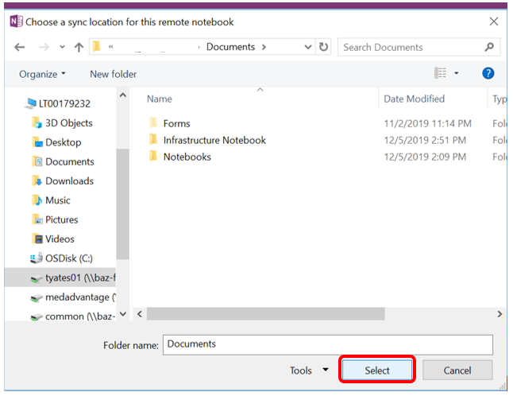

1. You will see the following dialog box:

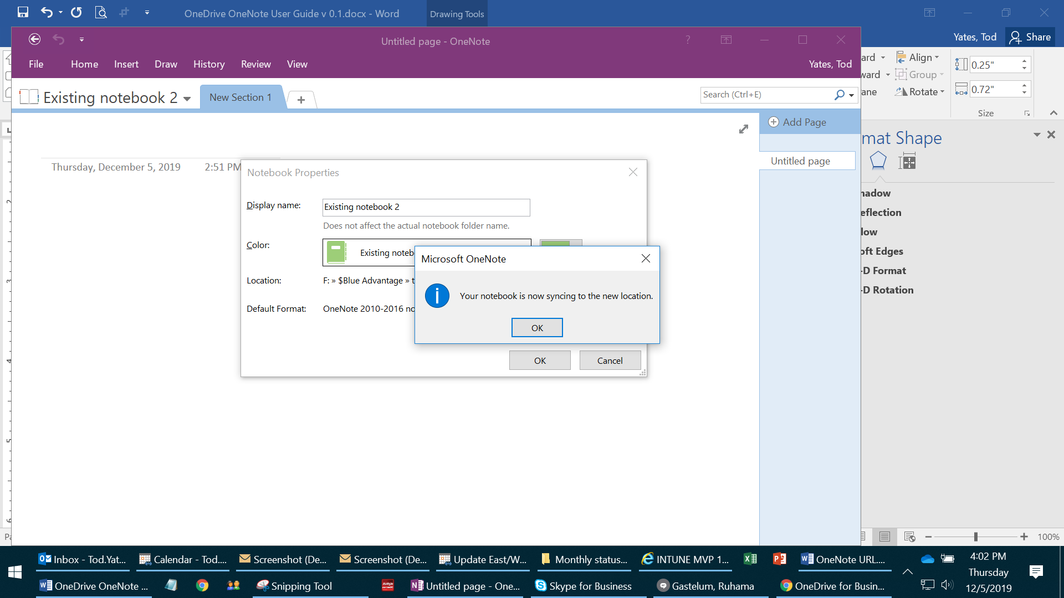

The notebook will be available in OneDrive on your devices (phone, tablet) and from the OneNote application on your laptop.

Note: Notebooks can be viewed through the web client in any browser, File Explorer or the OneDrive app on your mobile device.

